March 4, 2024
7:30 pm

“Mozart and Rising Stars”

MOZART
AND THE

2024 RICHARD RECORD RISING STARS CONCERTO COMPETITION WINNERS
– Celebrating 25 Years –

Overture to a Midsummernight’s Dream, Op. 21
Felix Mendelssohn (1809 – 1847)

Violin Concerto No. 2 in G Minor, Op. 63 - Allegro moderato
Sergei Prokofiev (1891 – 1953)

SECOND PLACE WINNER - Vladimir Tsiper

Piano Concerto No. 2 in G Minor, Op. 22 – Andante sostenuto
Camille Saint-Saëns (1835 – 1921)

FIRST PLACE WINNER - André Peck

INTERMISSION

The Dream Children, Op. 43
Sir Edward Elgar (1857 – 1934)

Symphony No. 41 in C Major, K. 551, “Jupiter”
Wolfgang Amadeus Mozart (1756 - 1791)

- Allegro vivace
- Andante cantabile
- Menuetto: Allegretto
- Molto Allegro

March 4, 2024
7:30 pm

“Mozart and Rising Stars”

MOZART
AND THE

2024 RICHARD RECORD RISING STARS CONCERTO COMPETITION WINNERS
– Celebrating 25 Years-

Overture to a Midsummer Night’s Dream, Op. 21
Felix Mendelssohn (b. Hamburg, Germany, February 3, 1809; d. Leipzig, Germany, November 4, 1847)

Felix Mendelssohn was a most precocious child. He was happy. His life was sheltered and carefully guarded. Heinrich Eduard Jacob writes in his book Felix Mendelssohn and His Times – Translated from the German by Richard and Clara Winston, “Even as a young boy and composer – pianist, he enjoyed fame. He had money that was his as the heir of a family fortune and was a genius. He was blessed from boyhood: he could devote himself entirely to his art.”

The boy was just 17 years old when he wrote the Overture to a Midsummer Night’s Dream. “Yet, his parents had also put an emphasis on the physical training of their young prodigy,” continues Jacob. “Felix had a gymnastics tutor – something not at all customary at the time – who himself was a pupil of the founder of gymnastics in Germany. In addition, Felix was a good swimmer and an enthusiastic dancer.”

At the age of 12, Mendelssohn was introduced to a musician in the Weimar court orchestra, Johann Christian Lobe. “The professional musician was amazed at Felix’ ability as a pianist and his talent for composition. The Lobe asked Mendelssohn to play something on the Streicher grand piano. It was decided that the boy would improvise on a theme that would be given to him.” Jacob writes, “The group was thunderstruck: the boy’s small hands worked into the masses of tone, mastered the most difficult combinations, and the passages rumbled and dropped like many pearls.”

Felix had a famous piano teacher, Ludwig Berger, an old pedagogue who treated perfection as something to be taken for granted. Yet, he was a good teacher in both piano and music in general.

“The Overture to a Midsummer Night’s Dream was originally composed as a piano piece for four hands (a duet) to be played by Felix and his sister, Fanny, together. Mendelssohn later arranged it for orchestra,” adds Jacob. “The orchestral version was given its first performance on February 20, 1827, with a sumptuous orchestra containing twelve first violins.”

Jacob writes, “Later analysis of the work notes that Felix, the romantic instrumentalist who in the Overture to A Midsummer Night’s Dream had gone almost further than Beethoven, Weber, and Schubert in exploring the potential possibilities of each instrument. He almost created a new art form,” concludes Jacob.

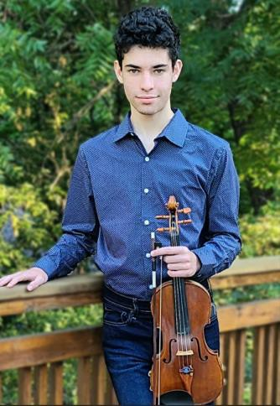

SECOND PLACE WINNER - Vladimir Tsiper

Vladimir Tsiper is an 11th grader at the Breck School in Minneapolis, Minnesota. He has been a student of Lucinda Marvin at MacPhail Center for Music since the age of five. In the last three years, he has also been taking lessons with Yulia Ziskel of the New York Philharmonic. Vladimir is also studying composition with Sarah Miller. He is a member of the Minnesota Youth Symphonies (MYS) Symphony Orchestra and the Artaria Chamber Music School.
Vladimir has won many prizes at venues such as Sherer International Competition, Schubert Club, Mary West Solo Competition, Thursday Musical, the MacPhail Concerto/Aria Competition, and Minnesota Sinfonia Young Artists Competition. In the last two years, he has performed with the Bloomington (Minnesota) Symphony Orchestra, the Dakota Valley Symphony Orchestra, the Civic Orchestra of Minneapolis, and the Minnetonka Symphony Orchestra.
The highlights of last season include Vladimir’s appearance on the national radio show From the Top, winning the MYS Solo Competition and soloing with the MYS in the Minneapolis Orchestra Hall, receiving the Jacobson Prize at the YPSCA finals, and becoming the West Central Division Winner of the MTNA Senior String Competition.

Vladimir also enjoys downhill skiing, theater, and traveling, especially visiting the tallest buildings in the world. He loves movies and is an active member of the film lovers’ community.

Violin Concerto No. 2 in G Minor, Op. 63 - Allegro moderato
Sergei Prokofiev (b. Sontsivka, Ukraine, April 23, 1891; d. Moscow, Russia, March 5, 1953)

Prokofiev composed this Violin Concerto in 1935 for the French violinist Robert Soetens. According to Michael Steinberg in his book The Concerto: A Listener’s Guide, “This work was Prokofiev’s last western European commission. He noted that the principal theme of the first movement was written in Paris, the orchestration completed in Baku, and the first performance was given in Madrid in December 1935.”
“He was composing the Concerto at the same time he was working on his ballet score Romeo and Juliet. In fact, we could almost imagine a page from one of the Romeo and Juliet notebooks had found its way into the sketches for the Concerto.” Steinberg continues, “Prokofiev continued to travel as conductor and pianist but was yearning to return to his homeland, Russia. In 1936, he, his wife, and their two children took an apartment in Moscow. One of his first projects was a modest work for a children’s theater: he called it Peter and the Wolf.”

Steinberg concludes, “The American Premiere of the Violin Concerto No. 2 with Jascha Heifetz was conducted by Serge Koussevitzky on December 20, 1937 with the Boston Symphony Orchestra.
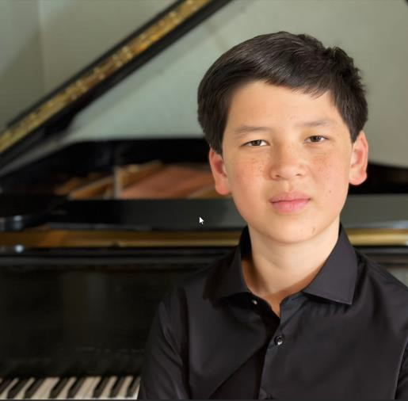 FIRST PLACE WINNER - André Peck

André Peck, a 14-year-old pianist from La Crosse, Wisconsin, began studying piano at age four with David Reedy at Reed Music Studios and is currently a student of Dr. Joseph Zins of Crocus Hill Studios in St. Paul, Minnesota.
André was named a ’23-’24 From the Top - Fellow by the legendary National Public Radio’s program, From the Top. He made his orchestral debut with the Fort Worth Symphony conducted by Miguel Harth-Bedoya. The Rising Stars with be his seventh orchestral performance after being named as a finalist for the upcoming The Final Forte in Madison (2024), semi-finalist at the International Young Artist concert competition Chicago (2024), First Prize in the St. Paul Piano Teachers Association Concerto Competition (2023), First Prize in the Minneapolis Mozart Teachers Forum Concerto Competition (2023), and the winner of the Piano Texas International Festival & Academy (2021 and 2022).

André has performed in the Piano Master Classes and in private lessons of such artists as Tamás Ungár, Asaf Zohar, Pascal Nemirovsky, Andrey Ponochevny, Igor Resnianski, Yoheved Kaplinsky, Mikhail Voskresensky, Gabriel Kwok, and John Owings.
He has given numerous solo recitals. Notably in June 2023, he presented a benefit concert for the Logan High School Band, raising more than $2,500 for instrument purchases. His interest in giving back to his community utilizing his pianistic gifts and his spirit of philanthropy, includes organizing Kid-Helping-Kids concerts for the La Crosse Children’s Museum and the Memorial Pool. He is currently a freshman at Logan High School. André also enjoys sports, mathematics, and chess and is enrolled in Linear Algebra and Software Design II at the University of Wisconsin-La Crosse.

Piano Concerto No. 2 in G Minor, Op. 22 – Andante sostenuto
Camille Saint-Saëns (b. Paris, France, October 9, 1835; d. Algiers, Algeria, December 16, 1921)

Camille Saint-Saëns composed his Piano Concerto No. 2 in 1868 and gave the first performance – he was the piano soloist – at a Concert Populaire in Paris on December 13th of that year, with Anton Rubinstein conducting.

Saint-Saëns was born in Paris. An aunt who played the piano gave him his first music lessons when he was three years old, and he immediately showed talent. He gave private recitals from the age of five, and at age 10 made his public debut. He continued studying piano and began organ lessons, later becoming an outstanding organist.

The Pianist’s Guide to Standard Teaching and Performance Literature by Jane Magrath, lists Two Little Piano Pieces – Berceuse and Largo composed by Saint-Saëns when he was only seven. Jane Magrath writes, “These works feature a depth of pathos remarkable from a child of seven.” The pieces are marked as being a Level 5.
Saint-Saëns wrote five piano concertos that reflect his own pianism (remember, he was an excellent pianist and organist) often using light pedaling or none at all. In fact, he is quoted in The Pianist’s Guide to Pedaling, “To play without the pedal calls for a degree of suppleness in the hands.” Richard Nicols writes about his technique in the BBC Music Magazine: “This light-fingered keyboard style had the virtue of lending itself to a contrast with the richer, louder orchestral sounds.”

British concert pianist and soloist Stephen Hough (born 1961) reports that Saint-Saëns is one of the most pleasurable of composers to play. Hough writes in his book Rough Ideas: Reflections on Music and More, that “having recorded the Compete Works for Piano and Orchestra by Saint-Saëns, he can attest to the fact that he wrote beautifully for the keyboard, but also wrote difficult ‘stuff’ so that he could show off!!”

Additional Prize Winners

$1,000 - Jay and Dawn Jaehnke Award - William Feng, Pianist, age 14, from Plymouth, Minnesota
$500 - John Bolstad Award - Tingyun Wang, Pianist age 14, from Roseville, Minnesota
$500 - Bill Koutsky Award - Selina Wen, Pianist, age 16, from Madison, Wisconsin

INTERMISSION

The Dream Children, Op. 43
Sir Edward Elgar (b. Broadheath, England, June 2, 1857; d. Worcester, England, February 23, 1934)
- Andante
- Allegretto piacevole

The score calls for two flutes, two oboes, two clarinets, two bassoons, four horns, timpani, harp, first and second violins, violas, violoncellos, and double basses. Duration is approximately seven minutes.

This work for small orchestra had its first performance at the Queen's Hall in London on September 4, 1902, conducted by Arthur W. Payne. English music critic Ernest Newman described The Dream Children as "a couple of delicate little pastels for a small orchestra, inspired by an essay of Charles Lamb, an English poet.”

Newman writes, "The two pieces are very short. The first is a tender little reverie with much lovely feeling underlying its simplicity. The second, is quite charming, and is more obvious in its sentiment. At the end of it there is a return to the theme of the first.” They are not complete symphonic movements but it was Elgar's practice to work in small sections and then put them together into a whole.
Sir Edward Elgar grew up in music surroundings, since his father was a musician; he was an organist and violinist who also founded a successful music-selling business. According to Grove’s Dictionary of Music and Musicians – Fifth Edition, “Young Edward gained a great deal of music experience in string music from learning his father’s violin, and wind instruments since he played the bassoon in a woodwind quintet. He also composed for the woodwind quintet and for the organ as well as church music.”

Symphony No. 41 in C Major, K. 551, “Jupiter”
Wolfgang Amadeus Mozart (b. Salzburg, Austria, January 27, 1756; d. Vienna, Austria, Dec. 5, 1791)

- Allegro vivace
- Andante cantabile
- Menuetto: Allegretto
- Molto Allegro

The score calls for one flute, two oboes, two bassoons, two horns, two trumpets, timpani, first and second violins, violas, violoncellos, and double basses.

Mozart’s last symphony, the Jupiter, was completed on August 10, 1788. It is not known whether Symphony No. 41 was ever performed in the composer's lifetime. It was written during a difficult period for Mozart: his personal finances were faltering, and his baby daughter died. The longest and last symphony that he composed; it is regarded by many critics as among the greatest symphonies in the era of classical music.

Yet, it is important for this evening’s “Rising Stars Concert” to review the very beginning of Mozart’s life and career – the two were intertwined. “Classical music is an art form that can’t help having one foot in the past and an eye on its family tree,” writes Joshua Barone in The New York Times. “You hear about piano teachers who can trace their techniques back to Beethoven (and his student Karl Czerny who wrote down his – and Beethoven’s – piano method). Lineage is crucial; influence, inevitable.” And we will read about that in Mozart’s case, too.
Leopold Mozart, young Wolfgang’s father, represented his son as a ‘miracle’– he was truly a child prodigy. Young Mozart had a sister slightly older than him named Marianne or “Nannerl” which was her nickname. “Wolfgang apparently liked all this musical training from his father,” writes Wolfgang Hildesheimer in his book Mozart – translated from the German by Marion Faber. “He knew no other life and demanded no other.” Hildesheimer writes, “Leopold was always aware that he had to take advantage of his children’s youth, for all too soon they would be musicians like any other.” Leopold writes in a letter, “Wolfgang, is probably the superior of the two siblings, but his childlike brilliance won’t last when he grows up, and thus the ‘miracle,’ would be gone forever.”

“Mozart’s father, Leopold, from the beginning of his son’s career, along with members of the Mozart family, preserved letters and documents to support this plan,” writes Robert W. Gutman in Mozart – A Cultural Biography.

“Leopold wrote letters to friends and continued writing to his son, Wolfgang Mozart, throughout his life,” writes Maynard Solomon, who authored the book, Mozart: A Life. “When father Leopold Mozart died at the age of sixty-seven, he still described Wolfgang Mozart as a ‘miracle.’ Yet Leopold had discovered, nurtured, and harnessed his son’s amazing powers.” Solomon continues, “Several eminent observers authenticated young Mozart’s gifts saying he ‘possessed premature and almost supernatural talents. The child was such an extraordinary phenomenon that one is hard put to believe what one sees with one’s eyes and hears with one’s ears.’”

The first few letters we shall review (written by Leopold to his friend) describes when the elder Mozart, Leopold, started to teach Nannerl (Mozart’s older sister) the clavier. Mozart was just three. He listened attentively and immediately after Nannerl’s lessons, made a beginning by picking out thirds at the keyboard. Soon after turning four, Wolfgang started to use Nannerl’s lesson book and made extraordinary progress on the clavier. When he turned five, his father introduced him to the organ.
At five years of age, he took up the violin using a miniature instrument he had been given. Young Wolfgang made astonishing progress, extemporizing from his piano lesson book! What made this child exceptional was his fine sense of pitch and his dexterity with the bow. He had doll-sized hands and tried to cope with both the clavier keyboard as well as the violin fingerboard. His chubby, short fingers could scarcely reach a fifth on the harpsichord. Amazingly, he started to play his own little compositions on both the keyboard and the violin at the beginning of his sixth year. Since little Mozart did not know how to notate his tunes, his father began writing little Wolfgang’s compositions on blank music pages of sister Nannerl’s exercise book, while teaching him basic music notation. Amazingly, some of those measures would end up thirty-one years later in his Requiem.

Solomon continues, “Leopold Mozart was to be his son’s main instructor in virtually every part of his education. Leopold had been an outstanding singer and a proficient violinist and served as a violinist in the Salzburg court orchestra. A poorly paid musician, Leopold began to give violin lessons and to compose. He eventually wrote a treatise on violin playing. This violin method written in 1755-56 was well received and translated into Dutch and French; later it had two more German editions (1769 and 1787) during his lifetime.”

“Ultimately, Leopold gave up his violin lessons and his composing so as to devote all the rest of his life to the education of his two children,” adds Solomon. “To all appearances, Mozart was a happy child.”
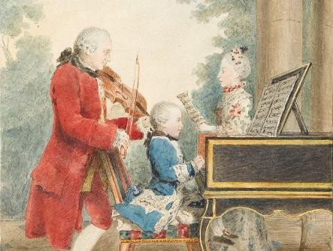
Leopold, Wolfgang, Nannerl Mozart What to Listen For
The name “Jupiter” was given to this work by an English impresario named Johann Peter Salomon. From its opening, the entire symphony – which is brilliant – has a weighty character that sets it apart from Mozart’s other symphonies. While the first three movements are beautiful, it is the ‘Finale’ that is most memorable and dazzling.
“The music moves at a tempo swifter than any we have yet heard in this symphony,” writes Michael Steinberg in The Symphony - A Listener’s Guide. “All the themes in this finale are short and Mozart whirls them by us with a fierce energy that is rooted in his dazzling polyphony which combines the distinct and independent lines of music all at once. The expressive intensity generated by that energy is exhilarating, shocking, and uplifting all at once.”
Steinberg continues writing that “six years earlier, Mozart had learned the music of J. S. Bach, giving him an understanding of Baroque polyphony which he had learned from his teacher Johann Christian Bach, Johann Sebastian Bach’s youngest son. In this ending, Mozart shows a dazzling glory of his mastery of polyphony.” The work concludes in a flourish of brass and timpani.

The first known recording of the Jupiter Symphony is from around the beginning of World War I, issued by the Victor Talking Machine Company in its black label series, making it one of the first symphonies to be recorded using the acoustic recording technology, according to the Discography of American Historical Recordings.

