LaCrosse Symphony Orchestra presents…
25th Annual Richard Record Rising Stars Concerto Competition

Saturday, January 20, 2024 Closed Preliminaries: 8:30am – 2:00pm (approx.)
Viterbo University – LaCrosse Open Semi-finals: 3:30pm

Eligibility: High school students (grades 9-12) from Wisconsin, Minnesota, and Iowa. (Students completing high school early are eligible if they are not currently enrolled in higher education at the time of the competition.) First-prize winner is not eligible to enter the year following their win.

Process: On January 20th, six semi-finalists from the closed preliminaries will be selected to compete in the open semi-finals that same day for the opportunity to advance to the final competition. Three students will be selected to advance to the March 2nd competition. The three finalists will perform during the first half of the LSO’s March 2nd concert. Prizes will be awarded following this performance.

Prizes and Awards: Two $500 cash awards will be awarded to two semi-finalists who do not move on to the finals. The three finalists will be competing for the following cash awards at the March 2nd concert:
- $2000 cash award
- $1500 cash award
- $1000 cash award

Repertoire: Only one movement is to be selected (unless otherwise specified) from the competition repertoire list. The movement must include parts of the introduction, cadenza (if applicable) and finale within the 10-minute period. This applies to preliminary and semi-final rounds.

Fee: Non-refundable $40 entry fee payable to the LSO must accompany the application form.

Rules:
- Music must be memorized and no longer than 10 minutes in duration. Appropriate cuts should be made and marked in the judge’s score.
- The entire movement will be performed with the LSO on the March 2, 2024 concert.
- All auditions must be done with piano accompaniment. Contestants are to provide their own accompanist.
- Bring one judge’s copy of the solo part. Numbering of measures is optional. Photocopies not allowed.
- Winners must be available to rehearse with the LSO on Thursday, February 29th and Friday, March 1st and to perform with the LSO on Saturday, March 2nd. Attendance at the Guest Artist’s Society event on Friday, March 1st from 5-6:30pm is also expected. (Please have a 3-5 minute piece that is fun for a small audience ready for that event. Your family members are invited to attend as well.)
- Applications must be postmarked no later than November 30, 2023 and sent with the $40 fee AND biography to:
Rising Stars Concerto Competition
c/o Janet Roth
350 20th St. S.
LaCrosse, WI 54601

For more information: Janet Roth at theroths07@msn.com
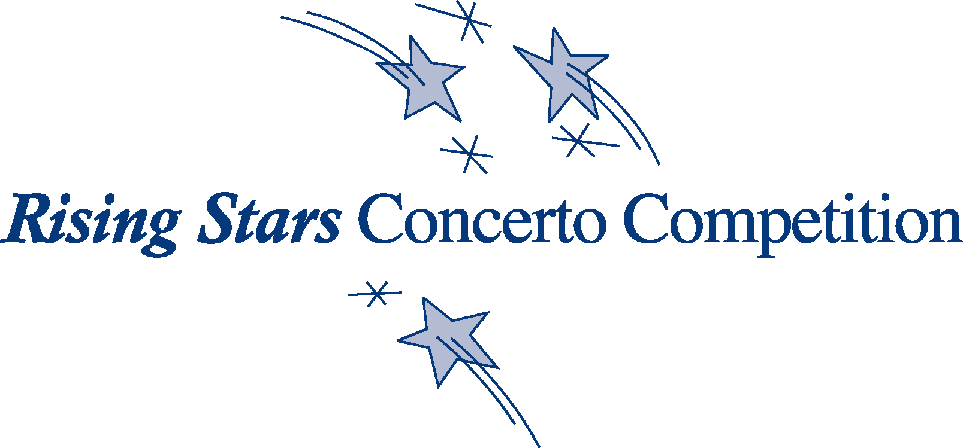

2024 Richard Record Rising Stars Concerto Competition Application

Name ____________________________________ Age_______ Phone (____) ________________
(At time of competition)

Address __________________________________________________________________________
Street City State Zip

E-mail address ______________________________________________________________________

Instrument _______________________________________ Years of Study ________________

High school ______________________________________ Grade in 2023-2024 ____________

Private Teacher Name and Email _______________________________________________________

Composer __________________________________________________________________________

Title of piece ________________________________________________________ Mvt. _________

Accompanist name & email ___________________________________________________________

Other students being assisted by this same accompanist? If so, who? ___________________________

__________________________________________________________________________________

Parent Signature _____________________________________________________________________

(Your parent/guardian signature authorizes the LaCrosse Symphony Orchestra to release the names and pictures of the participant to the media or for use on the LSO website and other publicity materials related to this competition and concert performance.)
Please enclose a personal biography with your application.

Application, biography, and $40 non-refundable fee must be postmarked no later than
Wednesday, November 30, 2023.
Make check payable to LSO.
Send completed application, bio, and check to:

Rising Stars Concerto Competition
c/o Janet Roth
350 20th St. S.
LaCrosse, WI 54601
4/25/23

